EXPERIMENT 2 :

Create a directory with name animal, now add 2 more directories an animal namely mammal and reptile. In mammal directory create files cow.txt and lizard.txt with 2 line of text in both the files. Now use mv command to move lizard.txt from mammal to reptile directory.

Step 1: **Create the animal directory**

mkdir animal



Step 2: **Navigate to the animal directory**

cd animal



**Step 3: Create mammal and reptile directories inside animal**

mkdir mammal reptile



**Creates two subdirectories**: mammal and reptile inside animal.

**Step 4: Create cow.txt and lizard.txt files in mammal**

1. **Create cow.txt:**

cat > mammal/cow.txt

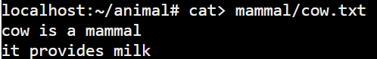

* + **Creates the cow.txt file** inside mammal and allows you to type content.
  + After typing content, press CTRL+D to save and exit.

1. **Create lizard.txt:**

cat > mammal/lizard.txt

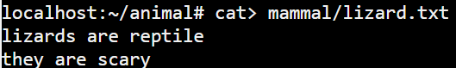

* + **Creates the lizard.txt file** inside mammal and allows you to type content.
  + After typing content, press CTRL+D to save and exit.

**Step 5: List contents of mammal directory to verify files**

ls mammal



* **Lists files** in the mammal directory to confirm cow.txt and lizard.txt.

**Step 6: Move lizard.txt from mammal to reptile**

mv mammal/lizard.txt reptile/



* **Moves** lizard.txt from mammal to reptile directory.

**Step 7: Verify the move using ls**

1. **For mammal directory:**

ls mammal

* + **Lists files** in mammal to confirm lizard.txt is gone.

1. **For reptile directory:**

ls reptile

* + **Lists files** in reptile to confirm lizard.txt is now there.
  + 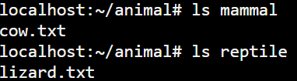

**Step 8: View contents of lizard.txt in reptile directory**

cat reptile/lizard.txt

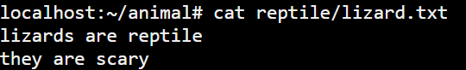

* **Displays the content** of lizard.txt now located in the reptile directory.

**Step 9: Check current directory path**

Pwd



* **Displays the current directory path** to confirm where you are.

**Step 10: Clear the terminal screen**

clear